

USE OF QUARRY DUST AND IRON FILINGS IN CONCRETE PRODUCTION

Ayo O. FAMILUSI^{1*}, Damilola A. OGUNDARE², Babatunde E. ADEWUMI³

¹Department of Civil Engineering, Federal University of Agriculture, Abeokuta
^{2,3}Department of Civil Engineering, Federal Polytechnic Ede

*Corresponding Author: ayomacfamilson@gmail.com

ARTICLE INFORMATION |  | ABSTRACT
Article history:  Received 04 October 2016  Revised 02 January 2017  Accepted 09 January 2017  Available online 20 February 2017 |  | The high cost of construction materials has necessitated the quest for alternative materials. This project is an experimental investigation into the effect of using quarry dust with iron filing as a partial replacement for fine aggregates [sand] in concrete production. A total number of 60 cubes of 1:2:4 mix of concrete was produced in varying materials proportions of 12.5%, 25%, 37.5% and 50% by weight of fine aggregates. It was revealed that both the materials-blended concrete and the conventional concrete produced at the chosen water-cement ratio of 0.55 have low workability. Method of curing by ponding was adopted and the compressive strength of quarry-dust-iron-filings-blended concrete with varying materials proportions of 12.5%, 25%, 37.5% and 50% at 28days of curing was found to be 11.86N/mm², 13.63N/mm², 15.92N/mm², and 17.27N/mm² respectively. There are no significant differences between the compressive strength values of the 37.5% and 50% quarry-dust-iron-filings-blended concrete and the conventional concrete and this actually justifies the use of the two would-be waste materials as sand replacements in concrete production.  © 2018 JNTCE. All rights reserved.
Keywords:
Iron Filings
Partial Replacement
Quarry Dust
Significant
Waste

1. INTRODUCTION
Quarry dust is a byproduct of the crushing process which is a concentrated material to use as aggregates for concreting purpose, especially as fine aggregates. In quarrying activities, the rock has been crushed into various sizes; during the process the dust generated is called quarry dust and it is formed as waste. So it becomes a useless material and also results in air pollution. Most of the developing countries are under pressure to replace fine aggregate in concrete by an alternate material also to some extent or totally without compromising the quality of concrete. Quarry dust has been used for different activities in the construction industry, such as building materials, road development materials, aggregates, bricks, and tiles (Savant, 2017). According to Assanduffconstruction (2016), the reduction in the sources of sand and the need to reduce the cost of construction projects have resulted in the increased need to identify alternative construction materials to sand as fine aggregates in the construction projects. Quarry dust, a by-product from crushing process during quarrying activities is a good alternative during construction projects. It is used as substitute to sand to make quarry dust concrete which is believed to be stronger and more durable than the regular concrete materials. It can be used as substitute to sand wholly or partly. It offers a comparatively good strength compared to sand with or without concrete admixtures. This type of dust is getting popular in construction projects such as road construction, building houses and making bricks and tiles. Quarry dust is ideal for these jobs and is expected to be the future and likely replacement for sand in construction project, since river sand is fast becoming scarce and very expensive. Sand is obtained from river beds, and its availability is becoming challenging at reasonable price. In order not to compromise strength of building during construction, quarry dust come handy as an equal substitute without threat to quality at the same time rendering good strength to whatever construction project, quarry dust is used for. Demand for sand from river beds is on the increase, so is getting too expensive daily; a construction project that utilizes quarry dust comes at cheaper cost and lesser pressure on market demand for sand. The shift in demand for sand in construction project is ongoing, and is not a surprise that this dust is the safe haven, with better innovation and inventions; it won’t be something unimaginable to see quarry dust replacing sand in the construction projects. In a similar vein, Balamurugan and Perumal (2013) in their study established that concrete acquires maximum increase in compressive strength at 50% sand replacement. It was also evident that quarry dust can be utilized in concrete mixtures as a good substitute for natural river sand with higher strength at 50% replacement. However, the reduction in the compressive strength of the quarry dust concrete was compensated by the inclusion of mineral admixtures into the concrete mix. In the presence of silica fume or fly ash, quarry dust can be a suitable partial replacement material to sand to produce concretes with fair ranges of compressive strength (Raman et al., 2015). The concept of replacement of natural fine aggregate by quarry dust could improve the utilization of generated quarry dust, thus reducing the requirement of land fill area and conserving the scarcely available natural sand sustainable development. Strength of the concrete is mainly dependent on bonding of the fine aggregates which fills the voids between the coarse aggregates. It is found that the strength of concrete is more for water-cement ratio of 0.45 when compared with water-cement ratio of 0.5. As the quantity of water increases, the compressive strength decreases when replaced with quarry dust. This is due to the water absorption property of quarry dust (Prakash and Rao, 2016). Ho et al. (2002) in their study on pastes and concrete mixes incorporating limestone or quarry dust where some comparisons were made, found out that the quarry dust, as supplied, could be used successfully in the production of self-compacting concrete. However, due to its shape and particle size distribution, mixes with quarry dust required a higher dosage of superplasticiser to achieve similar flow properties. Apart from quarry dust, another alternative material which is gradually finding its use in concrete works is Iron filing. Iron filings as described by Wikipedia (n.d.) are very small pieces of iron that look like a light powder. They are very often used in science demonstrations to show the direction of a magnetic field. Since iron is a ferromagnetic material, a magnetic field induces each particle to become a tiny bar magnet. The south pole of each particle then attracts the north poles of its neighbors, and this process repeated over a wide area creates chains of filings parallel to the direction of the magnetic field. Iron filings are used in many places including schools where they test the reaction of the filings to magnets. Industrial Research (2016) further corroborated that Iron filings are Iron particles usually smaller than 0.01 inch (0.3 millimeters). They are generally produced by filing, shaving, grinding or cutting iron parts; however, they may also be made of molten iron and certain iron ores. The most common uses of iron-filings are electromagnetism experiments, chemistry experiments, art works, powder metallurgy, fireworks (sparklers), concrete additive, and sand blasting. Iron filings are also used to make magnetic puttys, magnetic toys, artistic drawings, magnetic paint, heavy concrete, magnetic plastic parts and more. The main thrust of this research work is to determine the suitability of quarry dust and iron filings composite as a partial replacement for fine aggregates in concrete.

- MATERIALS AND METHODS
  - Materials and Equipment Used for the Study
The materials utilized for the study include Quarry Rock Dust (obtained from a quarry in Owo town, Ondo State, Nigeria), Fine aggregates (sand, obtained from Ede town, Osun State, Nigeria), Ordinary Portland Cement, Iron filings (got from some welding workshops in Ede town), Granite (consisting of hard, durable, uncoated inert particles, reasonably free from organic substances of 19mm size) and Potable water free of impurities. The apparatus and equipment used in the study include the metal moulds (with internal dimension of 150mm x150mm x150mm), Set of BS sieves, Hand Trowel, Tamping rod, Weighing balance, and Compression testing machine, Spanners, Slump cone, Head pans and Shovel.
2.2 Experimental Procedure
Batching and Mixing of Concrete
The mix adopted was 1:2:4, and the batching was done by weight. Appropriate proportion of concrete ingredients with the fine aggregates (sand) partially replaced by composite materials as depicted in Table 1. The mixing was done manually by turning the ingredients until an homogeneous mix of required consistency was achieved at 0.55 water-cement ratio. The process was repeated for all batches.
Sampling and Casting
Concrete cube moulds (150mmX150mmX150mm) were cleaned, internally lubricated and filled with freshly prepared concrete in three layers of approximately 50 mm thick. Each layer was compacted with 25 strokes using a tamping rod and the top surface was levelled and smoothened with a hand trowel. And for each batch, three specimens of concrete cubes were cast as shown in Plate 1.
Table 1: Details of Fine Aggregates Used for the Concrete Work
IF & QD Content (%) | Mass of IF (kg) | Mass of QD (kg) | Mass of Sand (kg) | Total Mass of Fine Aggregates (kg)
0% IF+0% QD | 0 | 0 | 30.09 | 30.09
2.5% IF+10% QD | 0.75 | 3.01 | 26.33 | 30.09
5% IF+20% QD | 1.50 | 6.02 | 22.57 | 30.09
7.5% IF+30% QD | 2.26 | 9.03 | 18.80 | 30.09
10% IF+40% QD | 3.01 | 12.03 | 15.05 | 30.09
Note: IF stands for Iron Filings and QD stands for Quarry Rock Dust
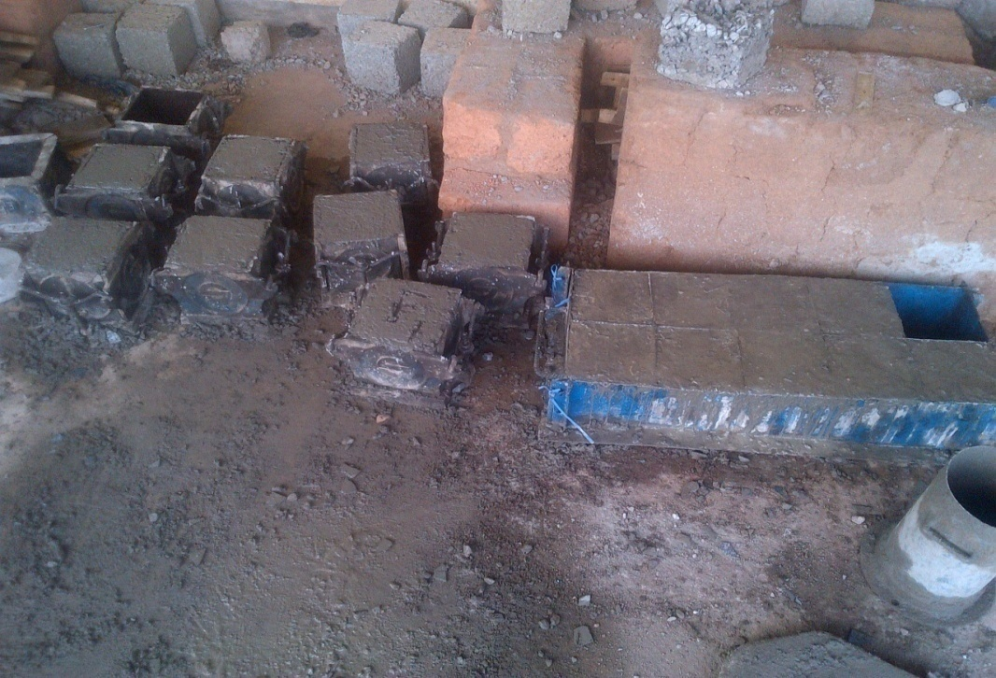

Plate 1: Concrete cubes placed in moulds
Curing
The concrete cubes cast were left in the laboratory at room temperature for 24 hours after which they were marked, demoulded and cured using ponding method for 7, 14, 21 and 28 days.
Determination of Workability of Concrete
The workability test was carried out by slump test which was performed in accordance with BS 1881 (1970) and the workability was determined through slump test and compaction factor test. The slump test as prescribed by BS 1881 (1970), was carried out on the fresh concrete. The slump cone after having been oiled, was later placed on a smooth surface with the narrower end of the frustrum facing the upward direction. The frustrum was then filled with fresh concrete in four layers, each layer was tamped 25 times with a standard 16mm diameter steel rod. The change/decrease in height was measured and recorded as the slump cone was removed from the concrete.
Determination of Compressive Strength of Concrete
The concrete cubes were removed from the curing tank and left for about an hour. After which each cube was weighed to know their mass, the concrete cubes (after being cured by ponding method for 7, 14, 21 and 28 days) were placed in the compressive strength test machine and the crushing load for each cube was recorded and its compressive strength also obtained.
Sieve Analysis
This test was carried out to determine the particle size distribution of the materials utilised as fine aggregates. 1000g of the specimen was air-dried, weighed and sieved through a set of standard BS sieves with aperture ranging from 37.5mm to 0.60mm with a receiver placed at the bottom of the sieves. The specimen placed on the top sieve was covered with lid, shaken manually for about 5 to 10 minutes and after the operation, the sieves were carefully removed to avoid loss of particles. The material retained on each sieve after shaking was then weighed by means of computerized weighing balance and recorded. The values obtained were used to plot the particle grading curve. Then the following analyses of the fine aggregates were obtained
Uniformity coefficient (U_{C}) = $\frac{D60}{D10}$
Coefficient of curvature (Cc) = $\frac{(D30)^2}{(D60 x D10)}$

- RESULTS AND DISCUSSION
3.1 Sieve analysis of the fine aggregates
The U_{C} and Cc values for sand were 4.44 and 1.01 respectively, while those for quarry dust were 4.70 and 1.05 respectively. This revealed that both aggregates are well graded.
3.2 Compressive strength of the concrete
The compressive strength of the cube specimen was calculated by dividing the maximum load at which the specimen fails by the cross sectional area. Average values of the three cube samples crushed at each age of curing were taken as the representative value. The compressive strength values are represented in Table 2 while it was evident from Figure 1 that the compressive strength first decreases but later increases in relation to increase in proportion of both quarry rock dust and iron filings.
Table 2: Compressive Strength Values (in N/mm²)
Age of Curing |  | 7 days |  | 14 days | 21 days | 28 days
0% IF+0% QD | 11.40 |  | 14.13 |  | 17.42 | 18.55
2.5% IF+10% QD | 7.85 |  | 8.42 |  | 10.26 | 11.86
5% IF+20% QD | 8.98 |  | 9.86 |  | 11.25 | 13.63
7.5% IF+30% QD | 11.20 |  | 12.44 |  | 14.05 | 15.92
10% IF+40% QD | 12.08 |  | 15.23 |  | 16.20 | 17.27

3.3 Workability of the concrete
The slump test (represented in Figure 2) reveals that the composite materials–blended concrete and the conventional concrete have a low workability at the water - cement ratio of 0.55 chosen.

Figure 1: Compressive Strength – Materials Content Characteristics for the Concrete Cubes at 28 days

Figure 2: Slump Value – Materials Content Characteristics for the Concrete Cubes

3.4 Statistical Analysis (Analysis of Variance)
Possibility of significant differences between the compressive strength values of the concrete cubes was determined through Analysis of Variance, the compressive strength values of the cubes at 7, 14, 21 and 28 days (as shown in Table 2) for each proportion (0%, 37.5% and 50%) were employed for this purpose and Table 3 was prepared by subtracting an assumed mean of 14.7 from all the compressive strength values. Table 4 rounds off the computation of F value as the ratio of mean square between treatments to mean square within treatments.
Table 3: Analysis of Variance in Compressive Strength
 | X₁-A | X₂-A | X₃-A | X₄-A | T_{j} | T_{j}²
A (0% CM) | -3.3 | -0.57 | 2.72 | 3.85 | 2.7 | 7.29
B (37.5% CM) | -3.5 | -2.26 | -0.65 | 1.22 | -5.19 | 26.9361
C (50% CM) | -2.62 | -0.53 | 1.50 | 2.57 | 1.98 | 3.9204
 | $$\sum{X_{jk}^{2}}=68.7045$$ |  |  |  | -0.51 | 38.1465
Note: CM stands for Composite Materials (Iron Filings and Quarry Rock Dust)

Where X₁-A = compressive strength at 7 days minus the assumed mean,
X₂-A = compressive strength at 14 days minus the assumed mean
X₃-A = compressive strength at 21 days minus the assumed mean
X₄-A = compressive strength at 28 days minus the assumed mean
$\sum{X_{jk}^{2}}=$(-3.3)² + (-0.57)² +…..+ 2.57² = 68.7045
V=$\sum{X_{jk}^{2}}$ – $\frac{T^2}{ab}$ = 68.7045 – $\frac{-0.51^2}{3X4}$ = 68.6828 (a=3, b=4)
V_{B}=$\frac{1}{b}\sum{T_{j}^{2}}$ – $\frac{T^2}{ab}$ = $\frac{1}{4}X38.1465$ – $\frac{-0.51^2}{3X4}$ = 9.5150
V_{W}=V - V_{B} = 68.6828-9.5150 = 59.1678
Table 4: Analysis of Variance in Compressive Strength (F Computation)
Variation | Degrees of Freedom | Mean Square | F
Between Treatments  V_{B} = 9.5150 | a-1=2 | S_{B}² = $\frac{9.5150}{2}$=4.7575 | F=$\frac{4.7575}{6.5742}$=0.7237
Within Treatments  V_{W} = 59.1678 | a(b-1)=9 | S_{W}² = $\frac{59.1678}{11}$=6.5742
Total V = 68.6828 | ab-1=11
F_{0.95}=4.26 and F_{0.99}=8.02
Since the values of F at 5% and 1% confidence levels are greater than the computed value, the null hypothesis is hereby accepted that is, there are no significant differences between the compressive strength values of the conventional concrete and those of the 37.5% and 50% composite materials. The statistical model establishes further that the iron filings and quarry rock dust could partially replace sand to 50% composition in the production of concrete.

- CONCLUSION
The slump value for the conventional concrete was 24mm and this was increasing with increasing proportion of iron filings and quarry dust till it reached 29mm (for the 50% proportion). The slump values signify a low concrete workability for the concrete batches at the chosen water-cement ratio. The conventional concrete cubes have the highest compressive strength value of 18.55N/mm² with the 50% proportion of replacement (by quarry dust and iron filings) having the compressive strength value of 17.27N/mm² which is the next in line. The use of quarry rock dust and iron filings as replacement materials in concrete really emphasises the importance of what could have been regarded as wastes.
5. ACKNOWLEDGEMENT
The authors wish to acknowledge the assistance and contributions of the laboratory staff of the Department of Civil Engineering, Federal University of Agriculture, Abeokuta toward the success of this work.
6. CONFLICT OF INTEREST
There is no conflict of interest associated with this work.
REFERENCES

Assanduffconstruction (2016). What is the Use of Quarry Dust in a Construction Project?

Retrieved from http://www.asanduffconstruction.com/use-quarry-dust-construction-project/

Balamurugan, G. & Perumal, P. (2013). Behaviour of Concrete on the Use of Quarry Dust to
Replace Sand – An Experimental Study. International Journal of Scientific and Research Publications, 3 (12): 1-4.

BS 1881 (1970). Testing Concrete: Slump Test. BS 1881 Part 2. London: British Standards
Institution.

Ho, D.W.S., Sheinn, A.M.M., Ng, C.C. & Tam, C.T. (2002). The Use of Quarry Dust for SCC

Applications. Cement and Concrete Research. 32 (4): 505-511.

Industrial Research (2016). Iron Filings. Retrieved from http://www.iron-filing.com/

Prakash, K. S. & Rao, C. H. (2016). Study on Compressive Strength of Quarry Dust as Fine
Aggregate in Concrete. Advances in Civil Engineering 1 (2): 1-5.

Raman, S. N., Zain, M. F. M., Mahmud, H. B. & Tan, K. S. (2015). Suitability of Quarry Dust
as Partial Replacement Material for Sand in Concrete. Retrieved from https://www.researchgate.net/publication/237806269_Suitability_of_Quarry_Dust_as_Partial_Replacement_Material_for_Sand_in_Concrete

